**Functional Document**

|  |  |
| --- | --- |
| **Application** | NGERP - Centra |
| **Service Bundle** | Sales Management |
| **Service Request** | Print Batch Invoice |

**Description :**

Print Batch Invoice is a form for generating XML for Promotion Invoice, Commercial Discount Invoice and Sales Credit Memo, which is sent to E-Invoice integration for acknowledgement.

**Workflow Process :**

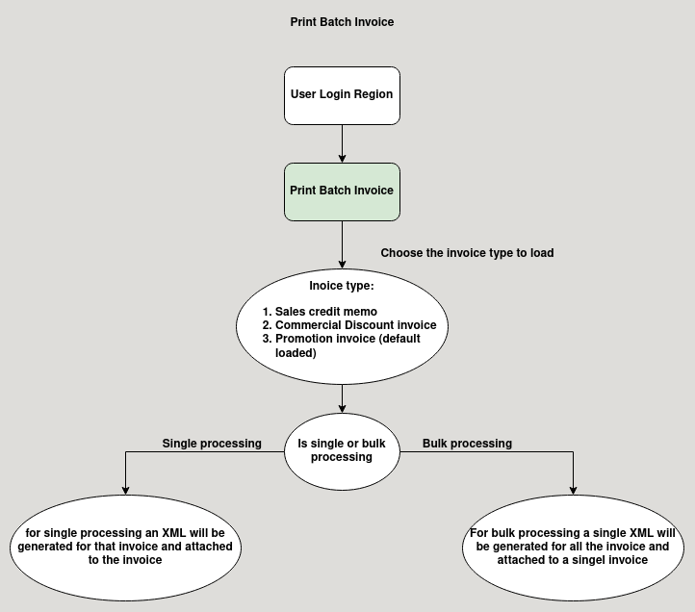

**Business Rules :**

* User Can access the Print Batch Invoice In Region Only.
* User can process singel invoice or multiple invoice in print batch invoice screen
* The maximum limit of invoice process at a time is 20.
* Tick the check box CDI commercial discount invoice to load the commercial discount invoice
* To load the sales credit memo tick the sales credit memo in the print batch invoice screen.
* Warehouse is mandatory for loading the invoices.
* After processing the invoice in print patch invoice screen a XML file will be attached in the invoice.
* If there are multiple invoice processed at the same time a singel XML will be generated for all the invoices and attached to first invoice the user selected.
* The XML will be sent for E invoice integration
* Import dms order to import and export the XML for Einvoice
* If the acknowledgement from einvoice has reversal the it will be updated in invoice.